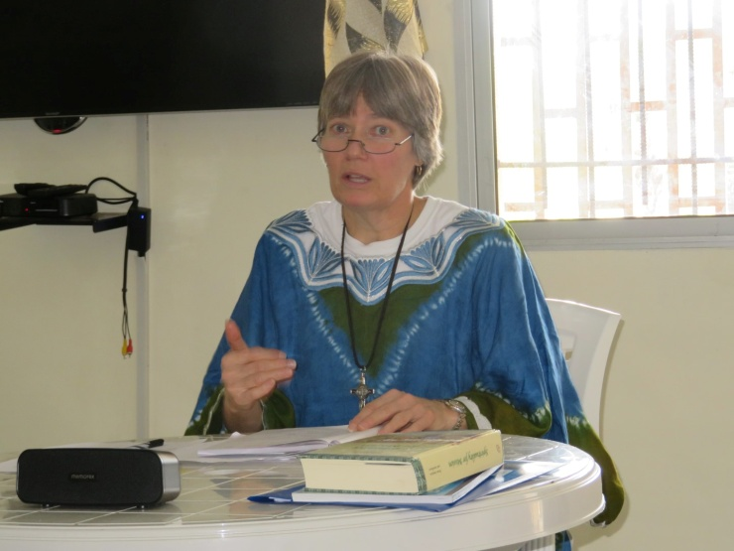
Beth Ann Otting
4 February 1964 – 29 January 2016

On 29 January 2016, Beth Ann Otting, SMA Lay Missionary, lost her life trying to save someone from drowning.
On 3 January 2016, Beth made a commitment with the Society of African Missions (SMA) to serve in Liberia. She left for Liberia on 4 January and was settling into her new mission life. Three weeks and three days later, Beth made the ultimate sacrifice – dying to save another. “No greater love than this . . .”
Beth was a very dynamic, warm, loving person: Soft-spoken, a great listener, and prayerful , she was a wonderful presence in the SMA community. Mission had been an important part of her life.
Beth was raised in a large extended family in Waukon, Iowa, where her relatives had been farmers. In 1986, she completed her studies at Clarke College in Dubuque, Iowa, in music and music education. From 1986 – 1990, Beth, talented and with a beautiful voice, served as a music teacher and a parish liturgist. Yet, from a very young age, she had wanted to do missionary service. When the opportunity came to serve in Africa with Habitat for Humanity International (HFHI) she jumped at the opportunity. From 1990 to 1998 Beth worked in Ghana as the Director of Field Operations, and for several years in Uganda as the Acting Country Director, with HFHI.
When she returned to the US she found employment with a loan company. At St. Joseph’s Church where she attended, the Parish Administrator, learning of her skills, found an opening in the parish working with liturgy and ministries. For several years she used her talents serving in different parishes as the Director of Liturgy and a Confirmation teacher.
From 2004 to 2010, Beth expanded her ministries, working with the bereaved as a Family Services Coordinator and receptionist. She was a compassionate presence to those grieving the death of a loved one. In 2011, Beth completed a one-year residency in Clinical Pastoral Education to become a chaplain. With that, she served as a Hospice Chaplain from 2011 – 2014.
From 2014 to 2015, Beth served in various capacities as she discerned what she wanted to do with her life. Always feeling the draw to return to mission in Africa, she contacted the Society of African Missions (SMA) and was accepted and entered the SMA Formation Program in September 2015. She made her commitment with SMA along with 3 other lay people, on 3 January 2016. The future was looking very bright for Beth and for SMA as she left the next day for her mission assignment in rural Liberia.
And then came her act of selfless assistance to someone in extreme danger. God called her home to her eternal reward. In accordance with her own desire, Beth will be laid to rest in Liberia, near the Cathedral Church (St. Theresa's) in Cape Palmas, after the Mass of Resurrection which will take place on 9 February 2016.
Deepest sympathy goes out to Beth’s family from her SMA family. She is survived by her father, Daniel Otting, and her seven siblings, Chuck, Pat, Mary, Kathy, Dana, Matt and Tom and their families: as well as aunts, uncles, and cousins. May God comfort and console all during this difficult time of loss. Beth will be greatly missed by her family and all who knew and loved her.
There will be a memorial Mass for her on 2 April at St. Patrick's Catholic Church in Waukon, Iowa. Mass begins at 4pm with a recitation of the Rosary before Mass.

